Project Title | Machine Learning–Based Anomaly Detection for Telecom Network Performance Data Ingestion Pipelines
- Introduction
The Technology Group of Dialog Axiata PLC relies on large-scale data pipelines to ingest daily telecom network performance management (PM) data from multiple Network Management Systems (NMS), such as Huawei U2020 and Ericsson ENM, into centralized analytics platforms like Microsoft Fabric. These datasets play a critical role in operational monitoring, capacity planning, fault detection, and strategic decision-making. However, such ingestion pipelines are inherently vulnerable to various failure modes, including connectivity issues, partial or delayed data transfers, schema mismatches, duplicate records, missing reporting intervals, and abnormal metric values arising from upstream system errors. When these failures occur, corrupted or incomplete data can propagate through downstream systems, leading to misleading insights and potentially flawed business decisions. Existing detection approaches, which are largely rule-based or rely on manual inspection, lack adaptability and require continuous maintenance, making them inefficient in dynamic environments. To address these challenges, this project aims to design and implement a machine learning–based anomaly detection system that operates at the data ingestion stage, enabling automated identification of anomalous patterns in incoming data batches. By detecting issues early and triggering corrective actions such as reprocessing or alert generation, the proposed system seeks to improve data reliability and enhance the robustness of downstream analytics, while contributing a practical, end-to-end solution to a real-world data science problem.

- Data Preprocessing Progress
Below summarized progress has been made in preparing the telecom performance dataset.

The below figure depicts a sample of anomalies that could be observed on the real data set during the initial data processing stage.
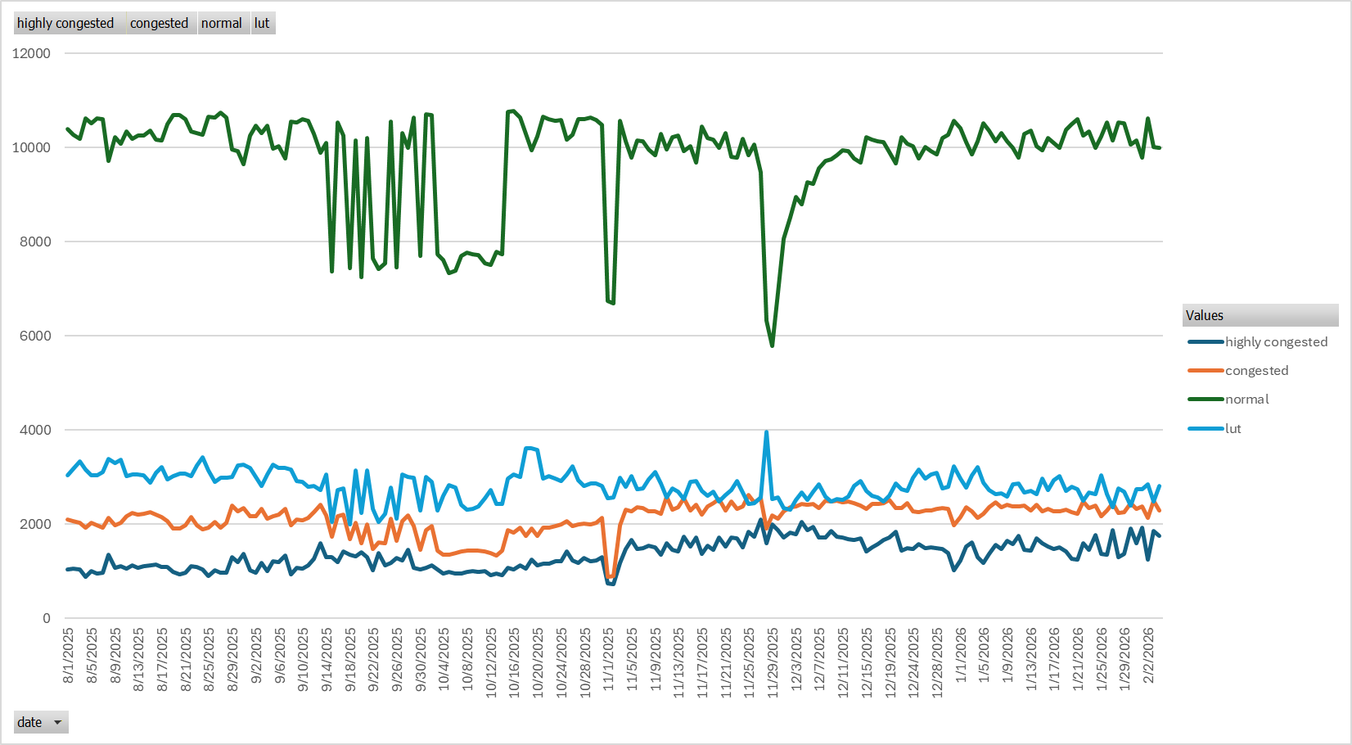

One of the key findings through the initial analysis is the presence of anomalies such as sudden drops, spikes, and missing intervals.

Therefore, the preprocessing had to focus primarily on,
- Missing value handling
- Outlier detection (Z-score, IQR)
- Time alignment and smoothing

Though the above approaches are used in preprocessing it is required to further finetune on next steps focusing on below aspects.
- Finalize anomaly handling approach
- Prepare the dataset for modeling

- Exploratory Data Analysis
The following areas were focused during exploratory data analysis stage.
- Time-series decomposition
- Lag analysis
Z score, IQR and rolling statistic approaches have been used at this stage, and improved methods like Random Forest, XGBoost and LSTM models are explored currently.

- System Architecture
System architecture and pipeline is planned as follows.

While the data preprocessing is mostly completed, I am currently working on feature engineering and modeling stages of the project.

- Summary
This is a brief elaboration of the current status of the project. By focusing more on advanced ingestion-stage detection, baseline-to-advanced model comparison, and reproducible evaluation, the project aims to deliver both technical depth and practical relevance expected through the capstone project.

